**Virtual Machines**

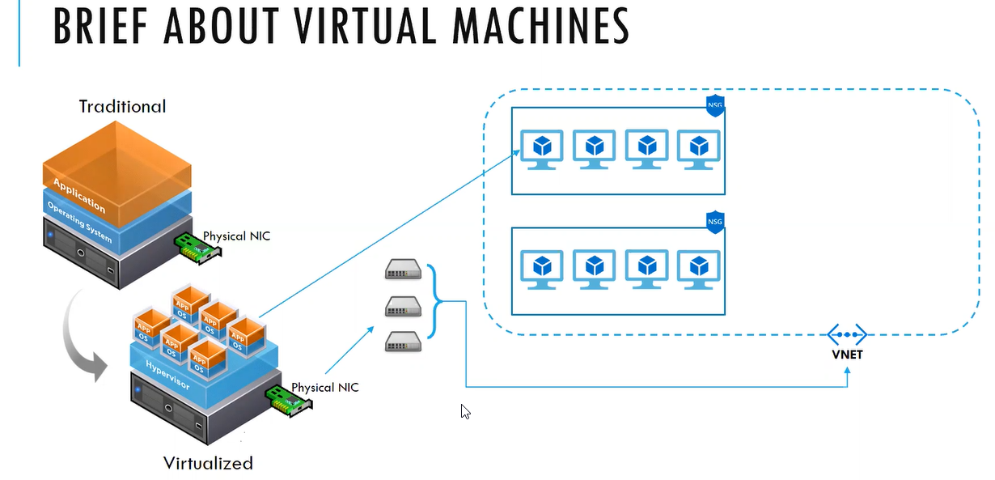

**Hypervisor** takes the control of hardware

For the VM a background hypervisor will run that is called Microsoft hyper v

Most of the companies which do not have Azure they will run on the hyper v

However azure hyper v is most advanced compared to normal hyper v layer

In the server rack number of hyper v (10-15) will be present

For the IAAS we don’t have control on the underline host. In the IAAS

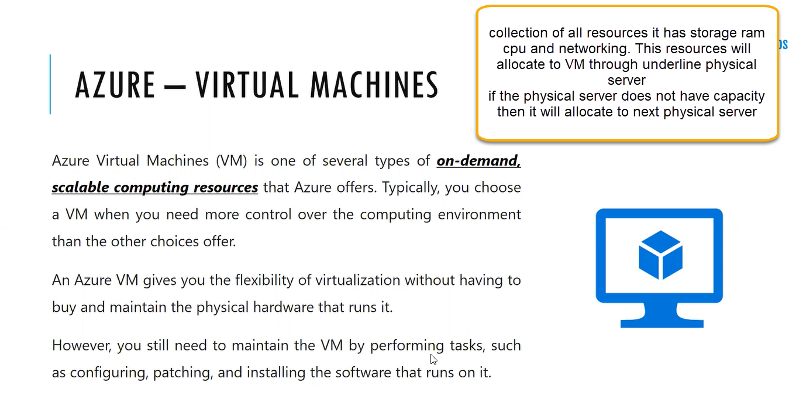

Azure has 60 footprints and 160 datacenters. Generally East Us most of the deployments will be happen and if you want to create the VM then we will get the error like resources not available and VM will not be created. However, it is managed because some of the people vm will be deleted

When creating the VM we can decide the storage, CPU and RAM. On premises total control will be private cloud which will be totally controlled on our side

In azure they have mention the specific templets don’t have customization regarding the size( Collection of resources, how much CPU, RAM and storage is required for that and how much bandwidth is required for networking )

When using the Azure we don’t have access to hardware and software (under line ) azure will take care everything and automatically upgrades everything

However inside the azure Virtual machine operating machine, applications patching and configurations will be maintained by end user

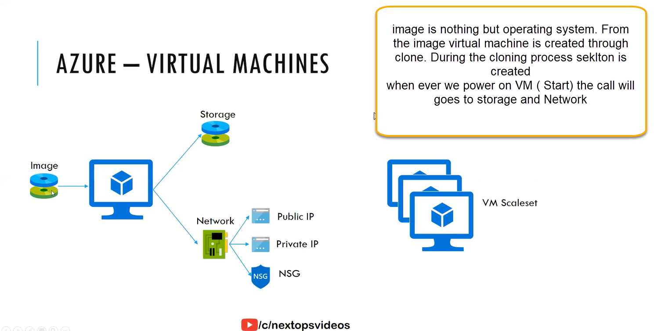

Storage will come from network storage area network each disc will come from network storage does not from local physicalhardware. Networking and CPU and RAM will come from underline physical server

And we can decide if we need any storage encryption

If we are deploying multiple VMs then it is called VM Scaleset

Auto scalability application need VM Scaleset ( like hosting IRSTC Web application) in a day some hours the application needs demand and some hours we don’t need demand

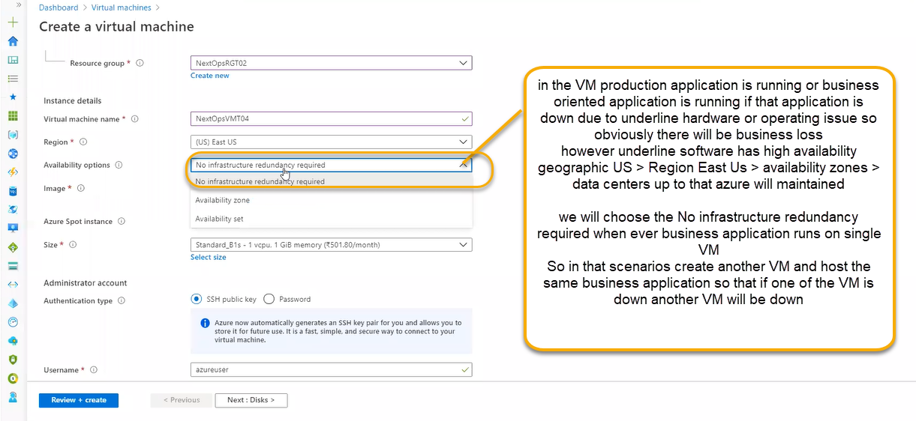

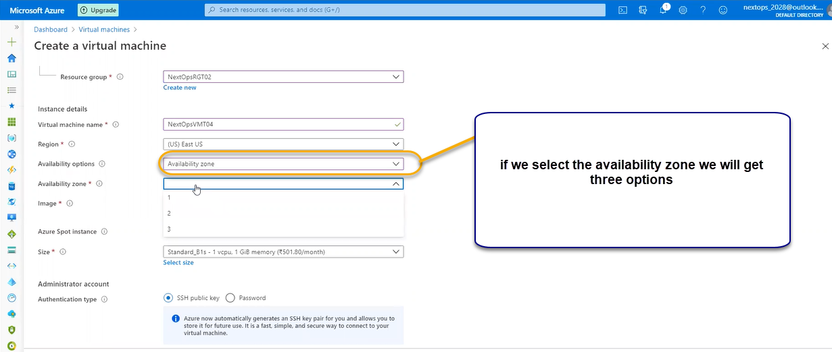

We will host the application and we will complete the deployment

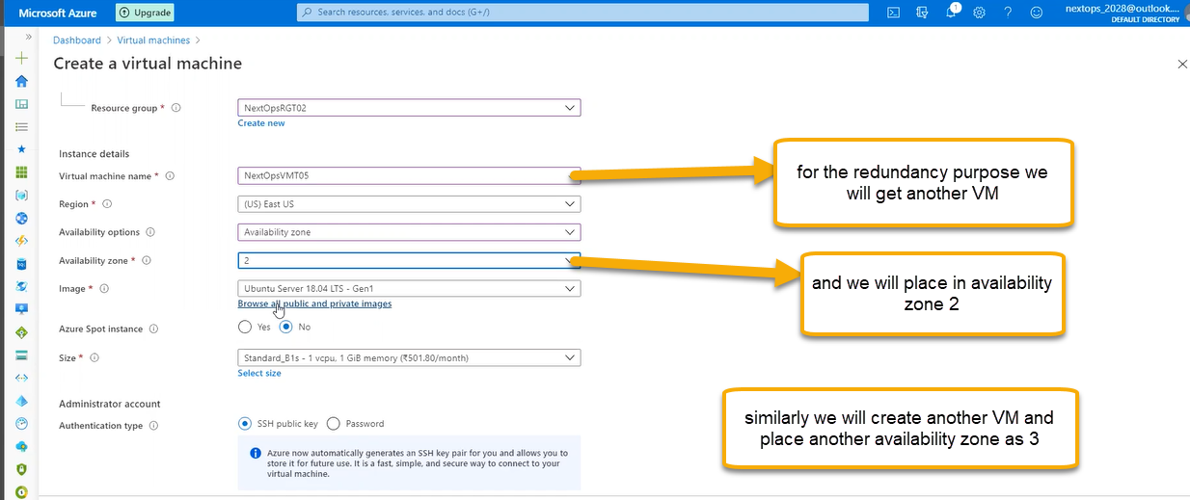

Or if high calamity occurs, we can create the similar VMs in the another Region

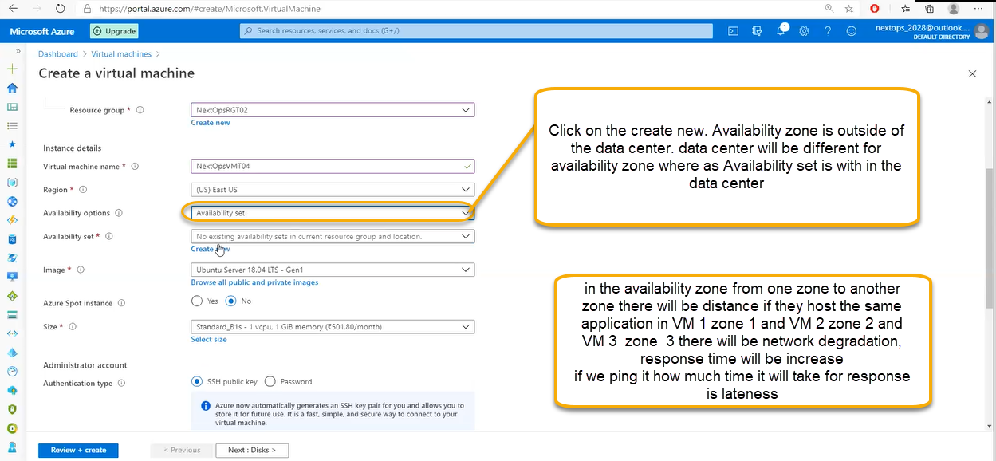

In the availability zone if the distance is increased then lateness will be increased for that reasons we will create the available set which is with in the datacenter ( in the same datacenter, same availability zone vms will be placed)

First vm will be placed in one rack and another vm will placed in another rack and so on

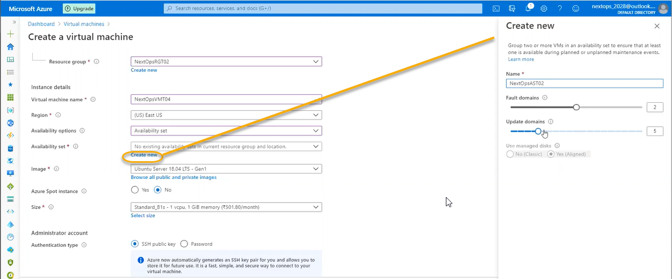

Fault domain is nothing but Racks. In the racks there will be multiple hyper v servers

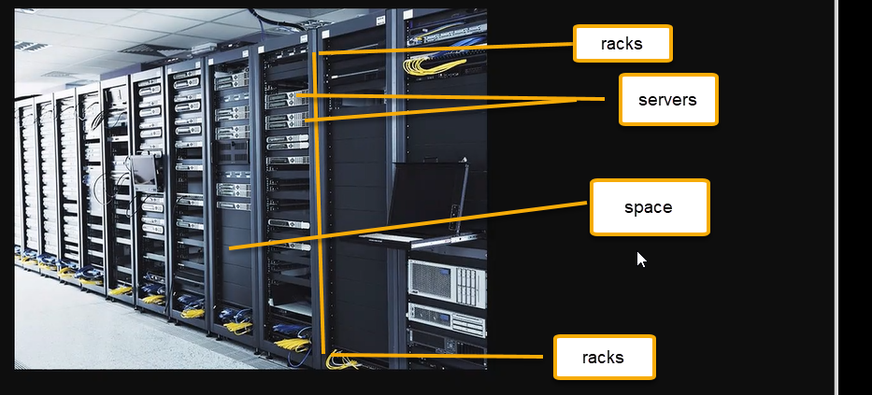

In the hyper v servers we will run the Virtual machines

Azure data centers will be placed where is there is less calamity and placed in large areas. They need power supply, cooling and everything is maintained by Microsoft

Collective of datacenters is availability

Collective of availability is region

Collective of regions is geography

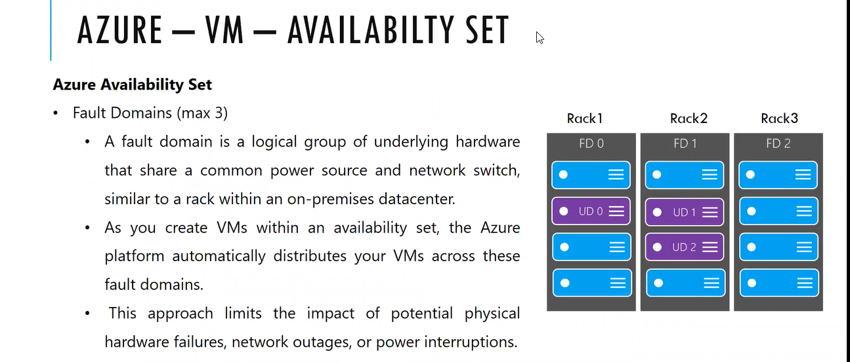

Each Rack is fault domain. Fault is a problem which may occurs due to power supply and network

For the Rack 1 there will be one or 2 power supply that power supply will be shared to all the servers

Through switch all servers are connected upper is networking and lower is storage. All the servers present in rack 1 will contribute same network and power supply

If we select the fault domain as 3 and created the VM

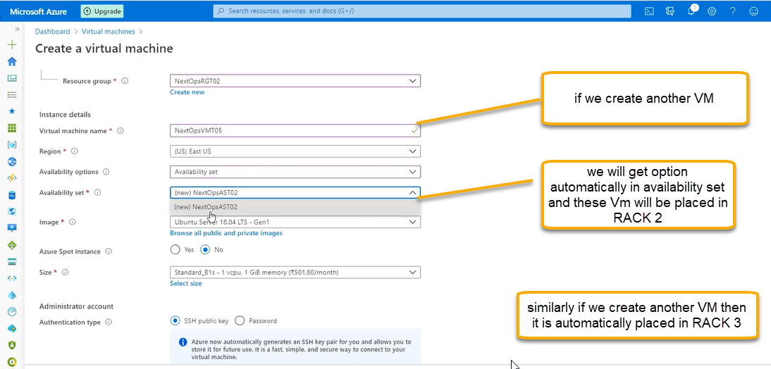

The reason for the setup is if any one of the rack is failed then we have a backup another two racks

Availability zone is high available which are placed in different data centers and the cost is high however Availability set is which is in the region same datacenter will be placed

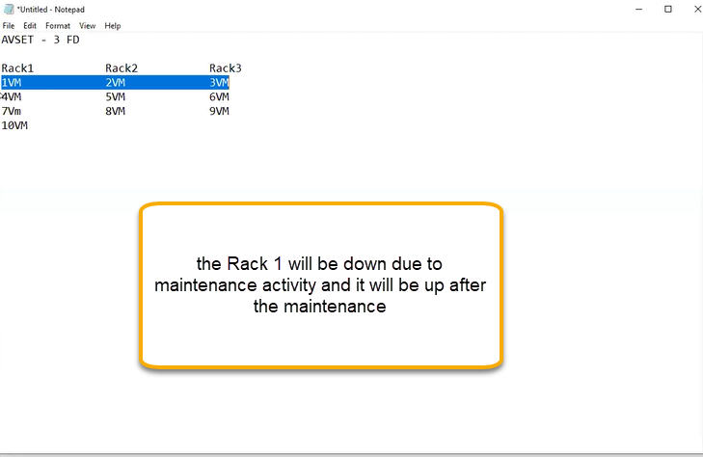

**Update domain** is server failure. Last component is server in the racks. planned/unplanned maintenance

Update domain primary work is Azure will do periodically update software or hardware which is planned maintenance. Azure will send the notifications this week there will be planned maintenance according plan yourself for high maintenance

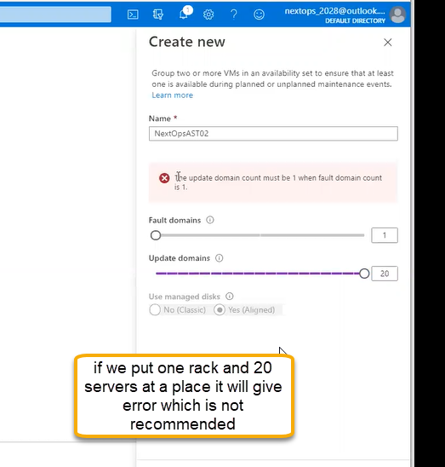

fault domain is rack level distribution and update domain is server level distribution

how many servers we need to place on each rack more number of racks indicates high availability zone

(2-5) and (3-20)

Once we place any VM in Availability set we cannot delete in the same way once we place any VM in No infrastructure redundancy required we cannot change to availability set

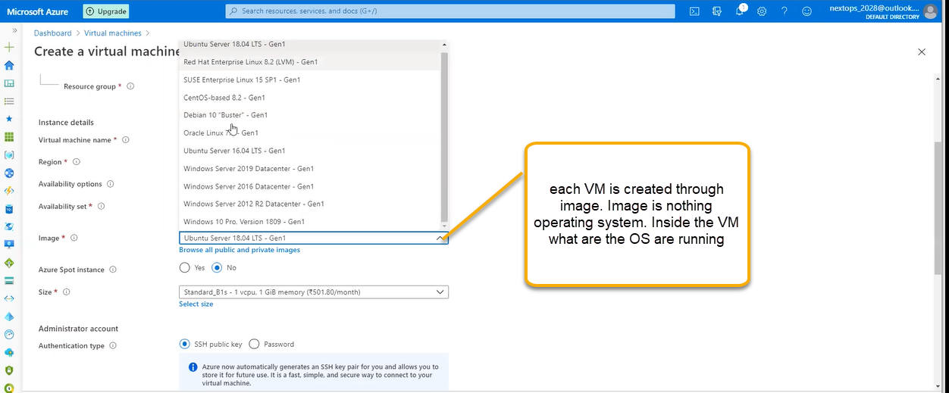

We can create our own images we will create one VM and login to that VM based on organization requirements we will configure VM and then we will shutdown that VM and we can create that image

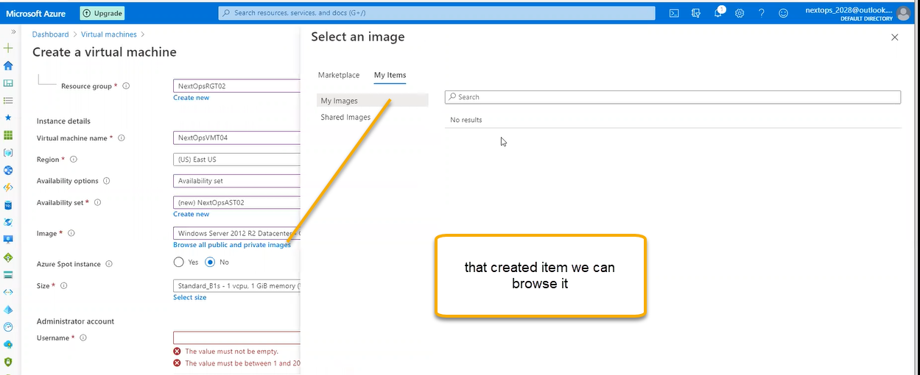

Each organization has separate tools like communicator slack, skype. For each system the application needs to be present is the requirement we will create one VM based on Azure Default image we install all software’s on that VM through that we will create an image

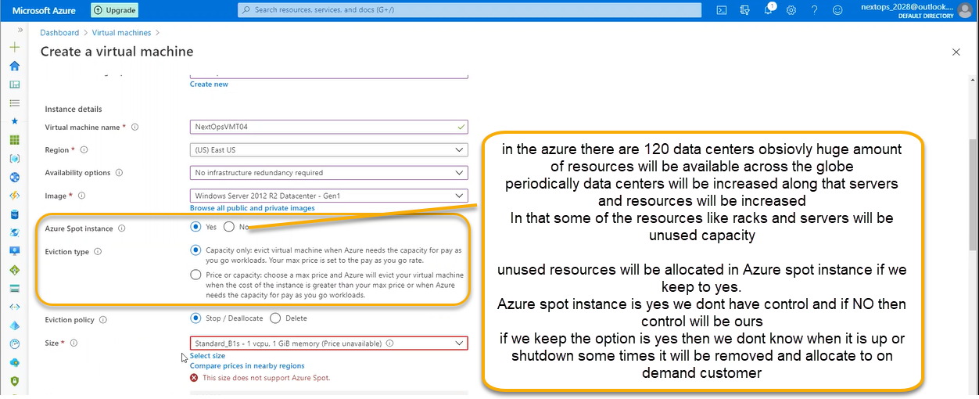

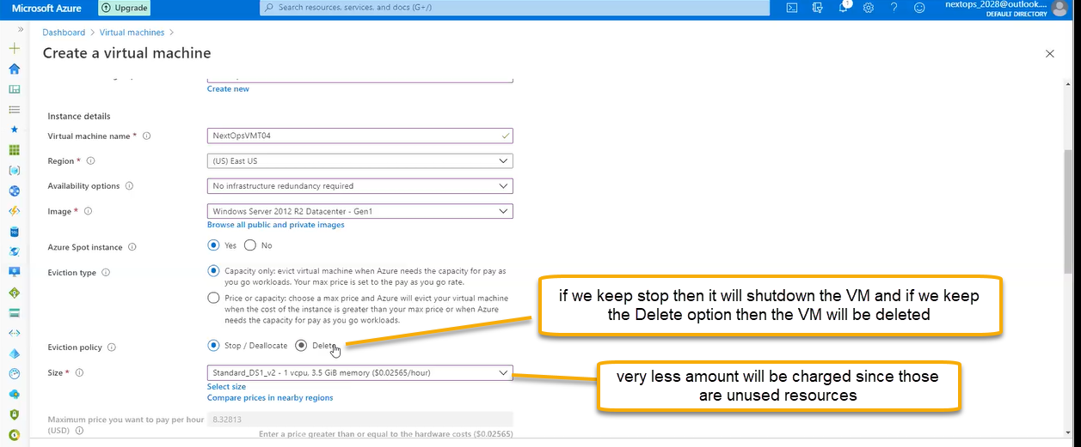

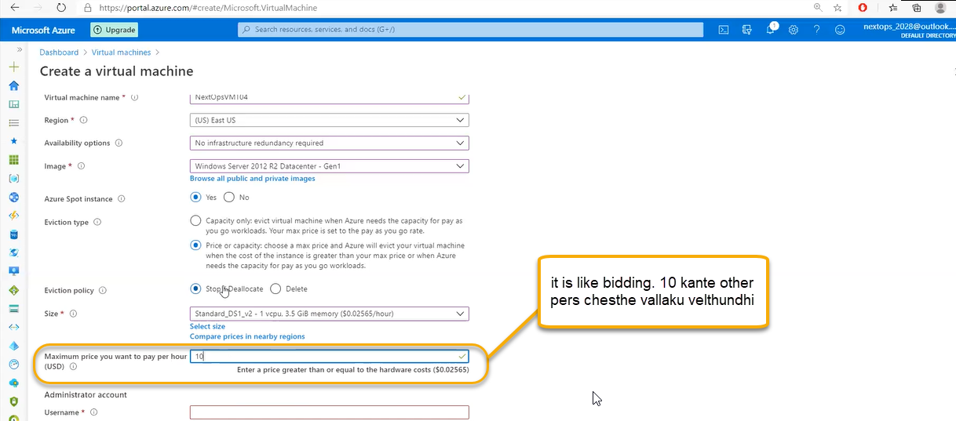

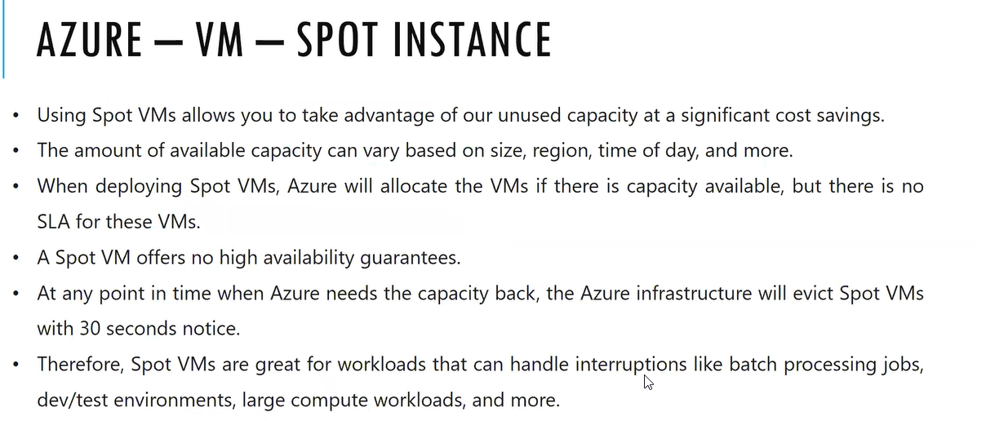

Azure spot instance if yes then there will be down time do not use for production

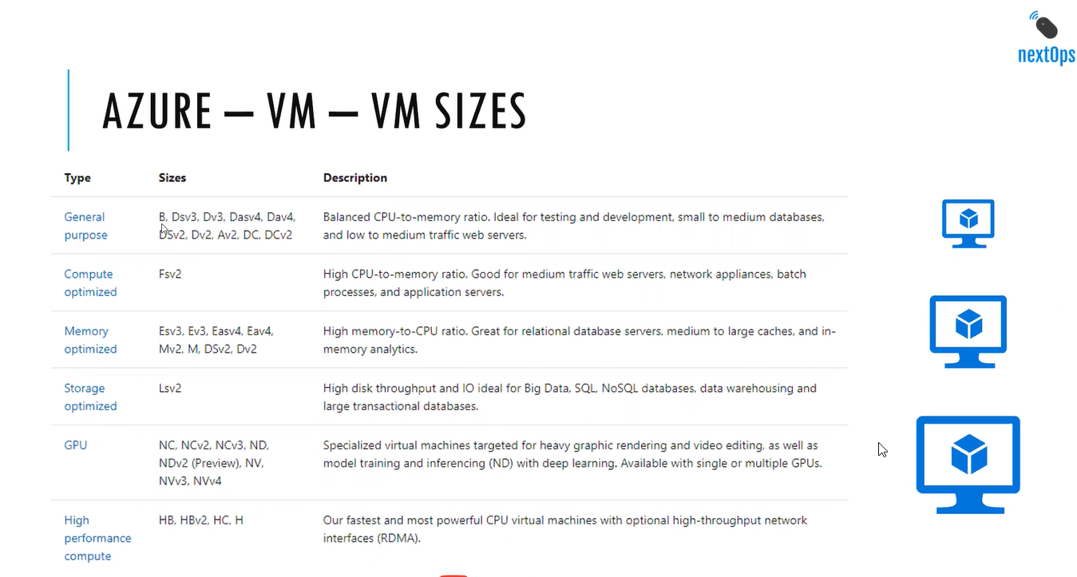

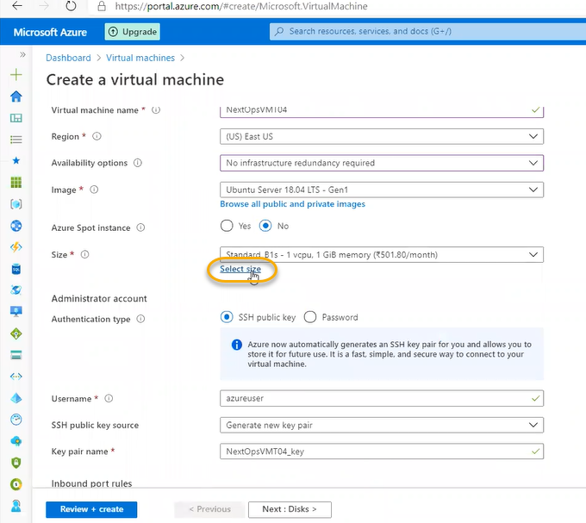

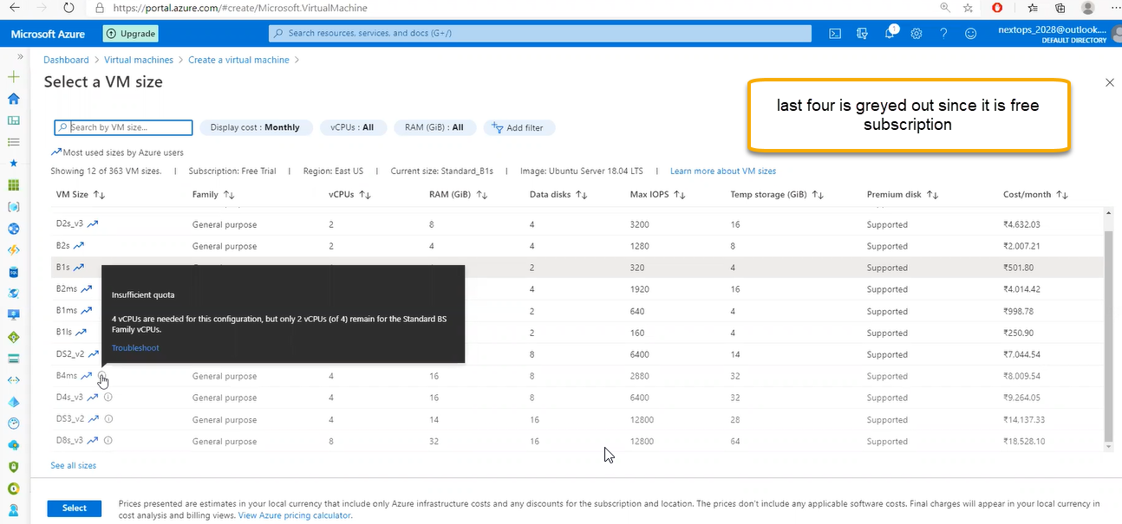

Single Vm highest resources to run is better than multiple vm running on different resources. We can switch one Size to another size however we need reboot for this

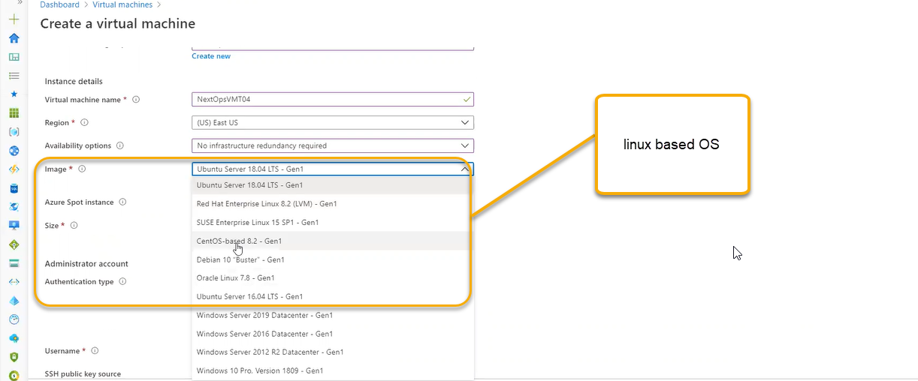

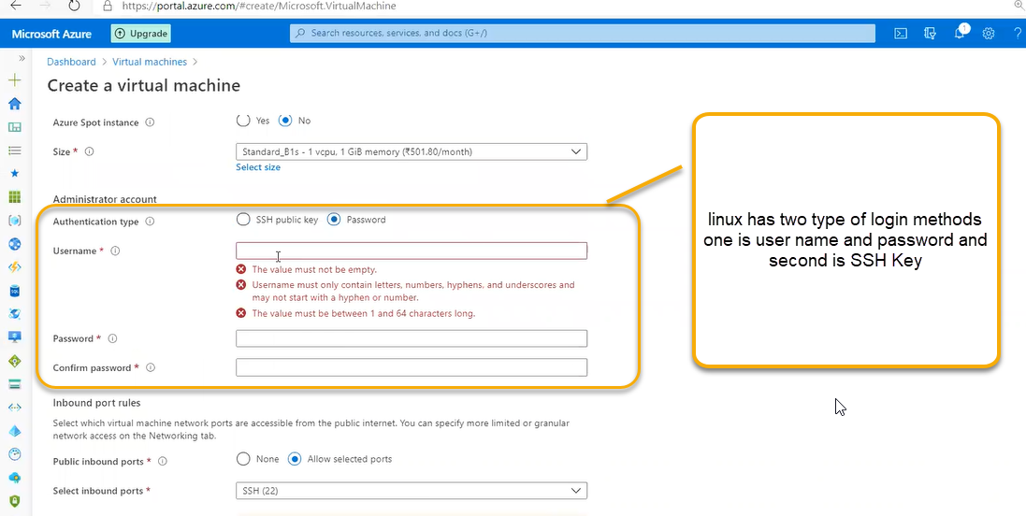

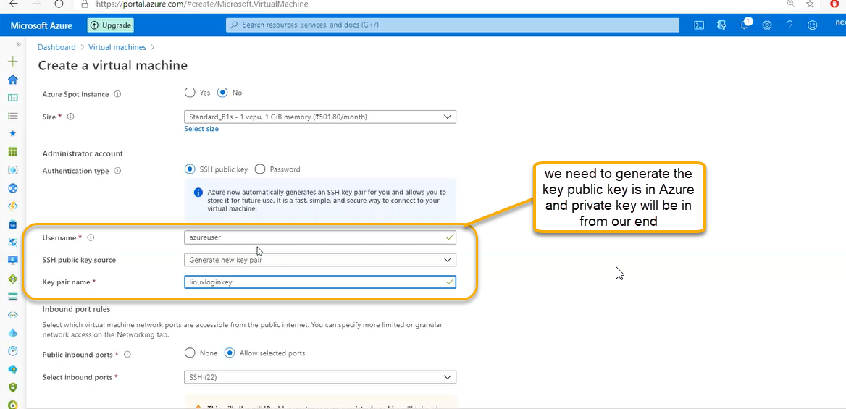

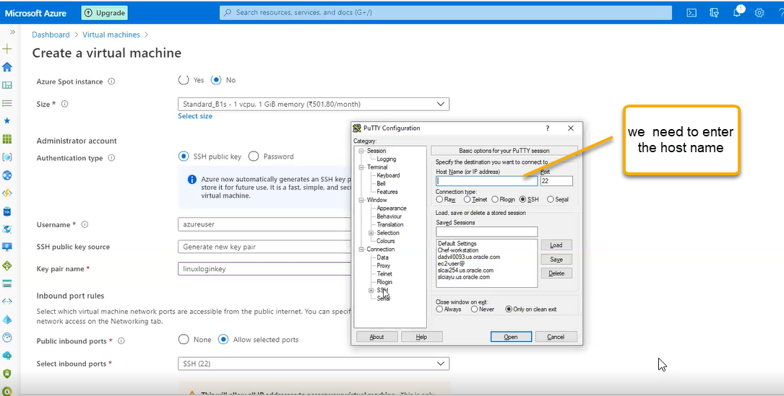

We need to mention the Machine Ip address

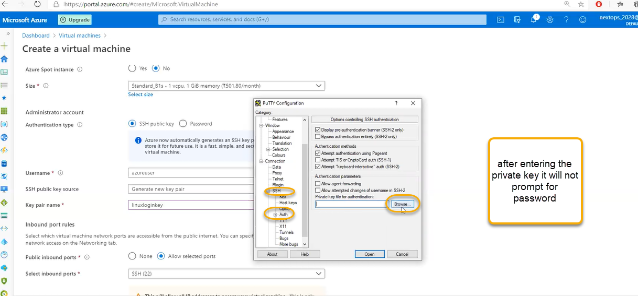

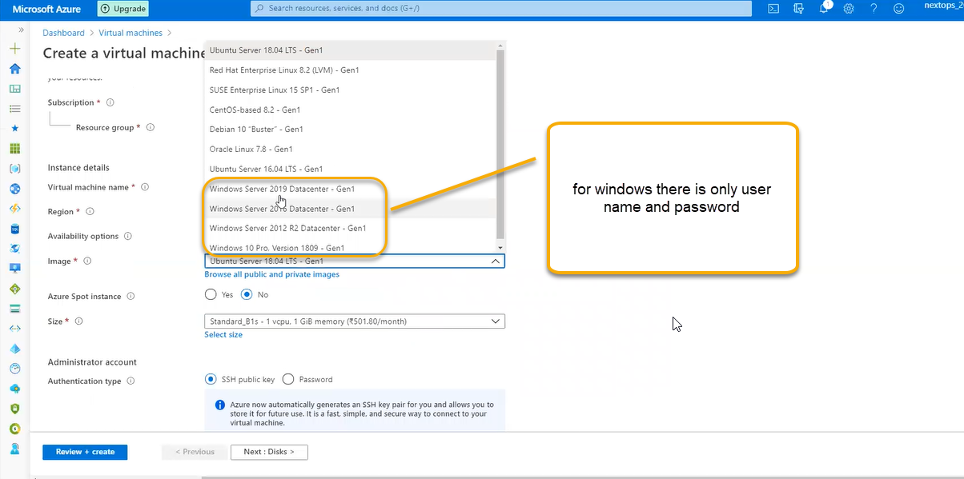

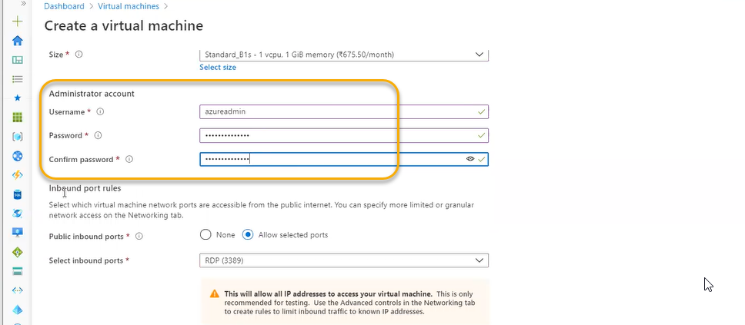

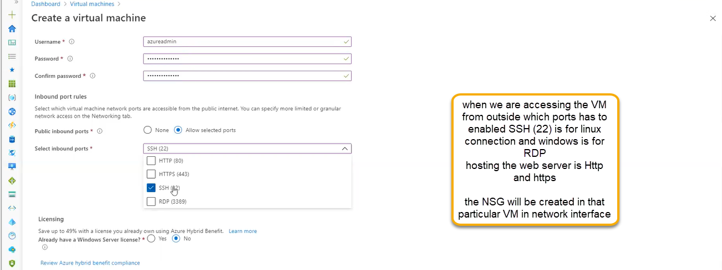

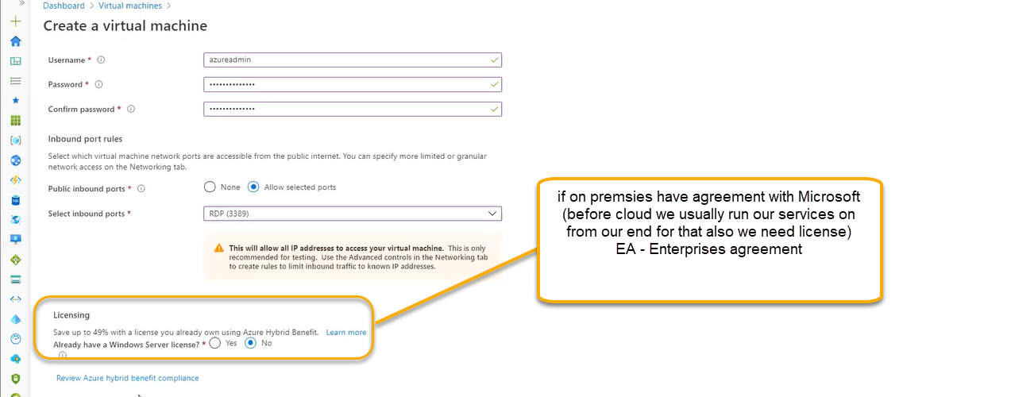

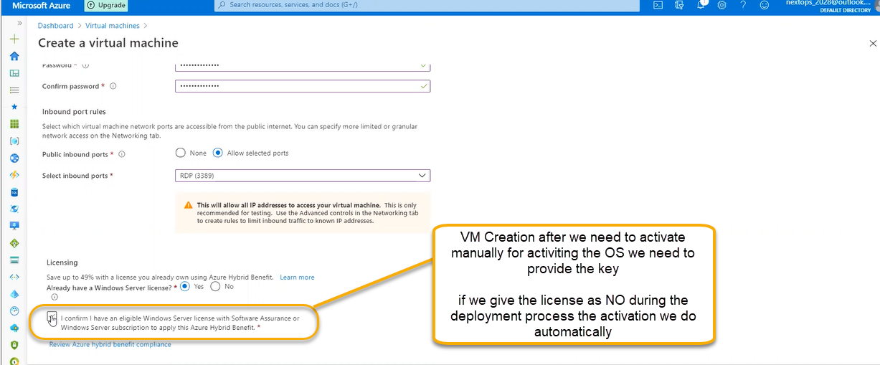

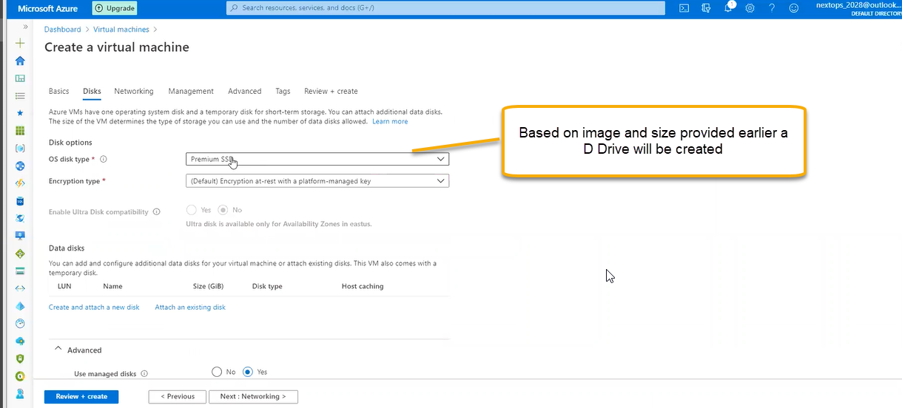

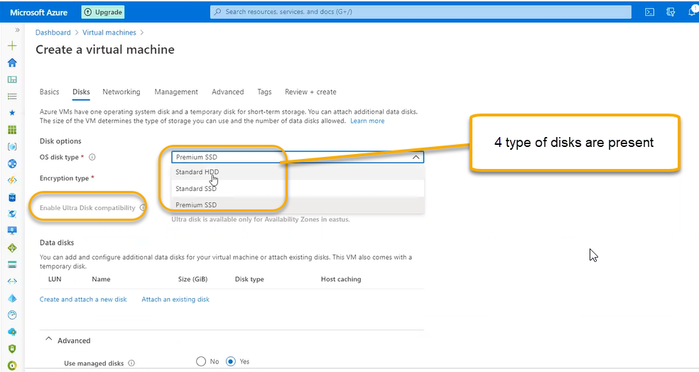

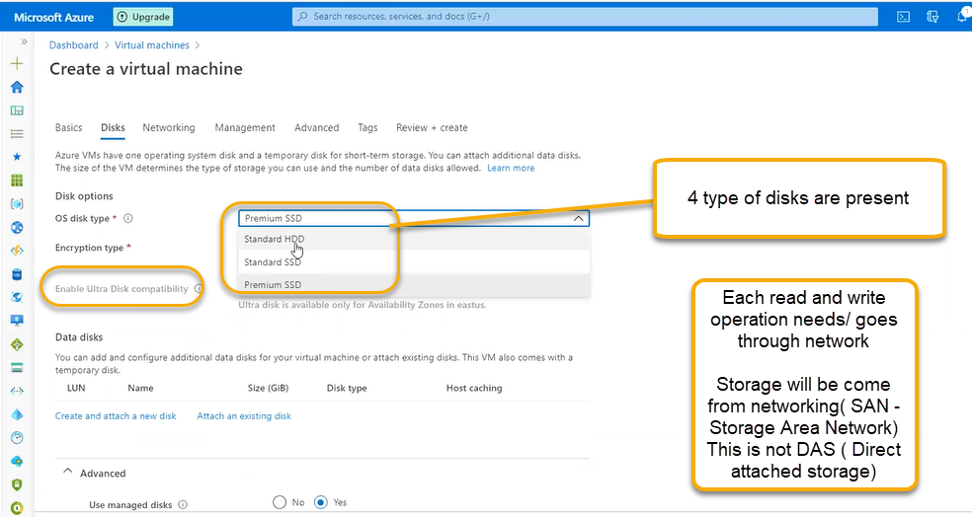

If we place the storage in the network the read and write will be gone through networking called network card. Each VM has interface. Regular network operations will use normal network card

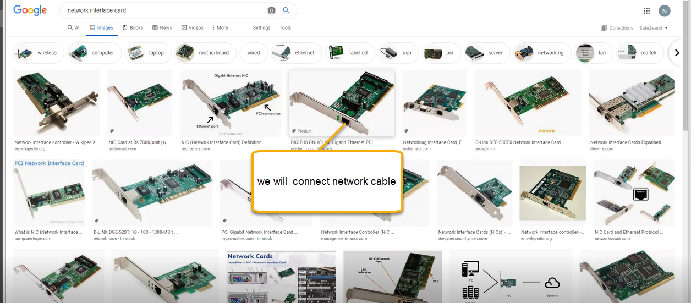

However, for storage operations we need HBA Card

For storage operations we have storage card those are HBA Cards

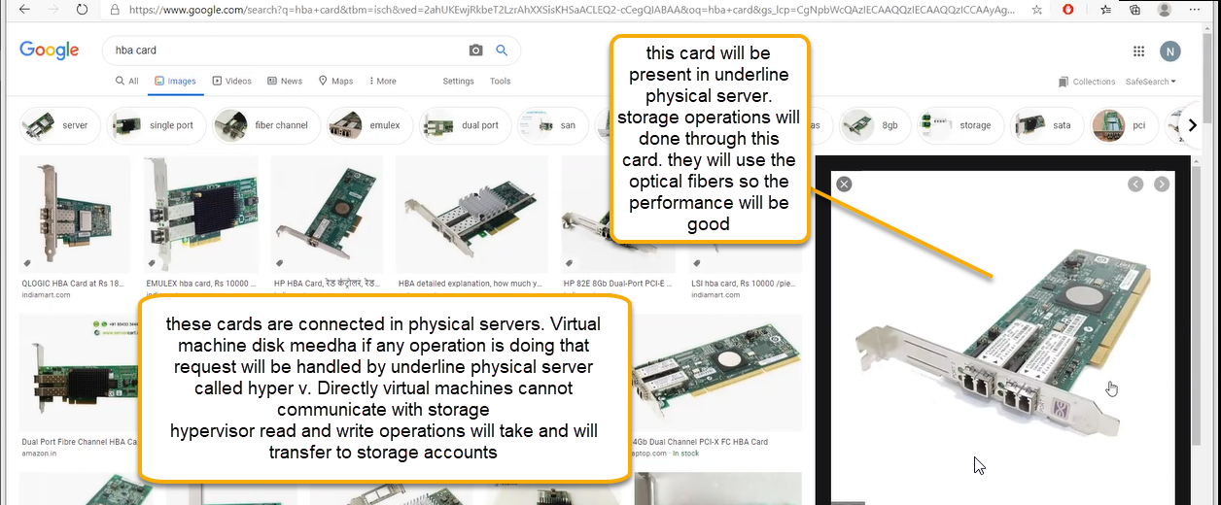

If we login to VM we have disk local c and local d that will come from network. Performance impact will be there to minimize that we are placing highest performance disk like ultra disk

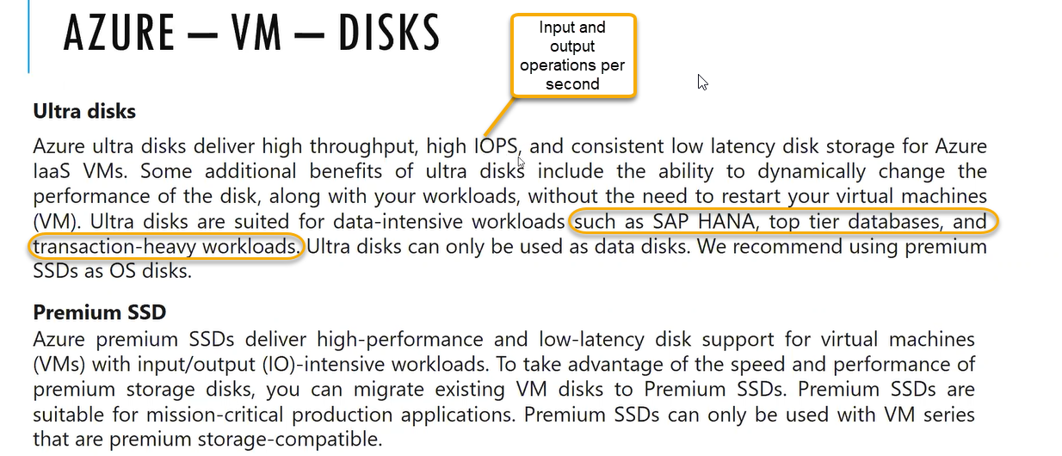

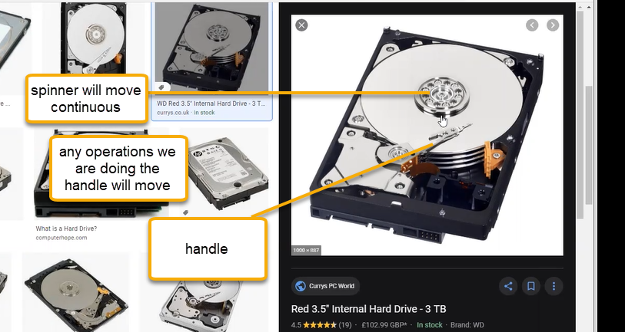

Disk performance based on rotation 70 to 100 RPM 15000 RPM 10000RPM

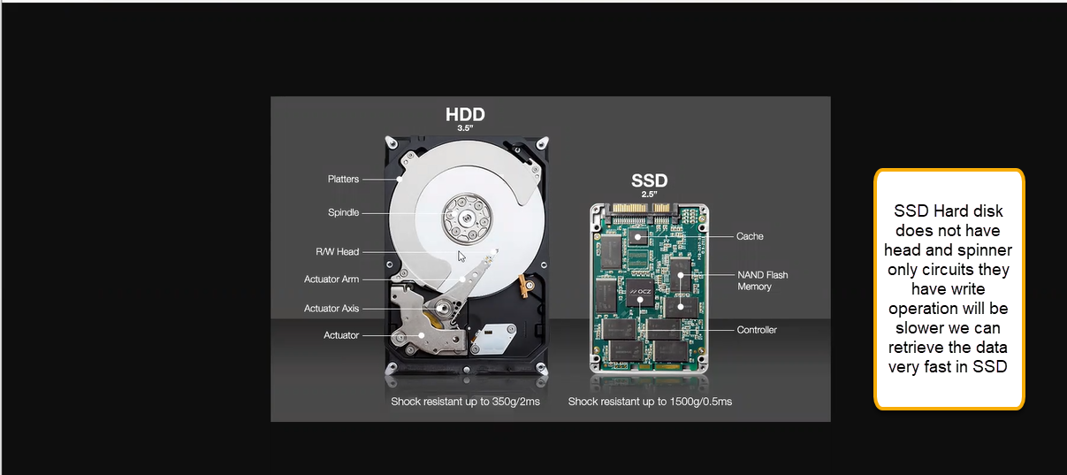

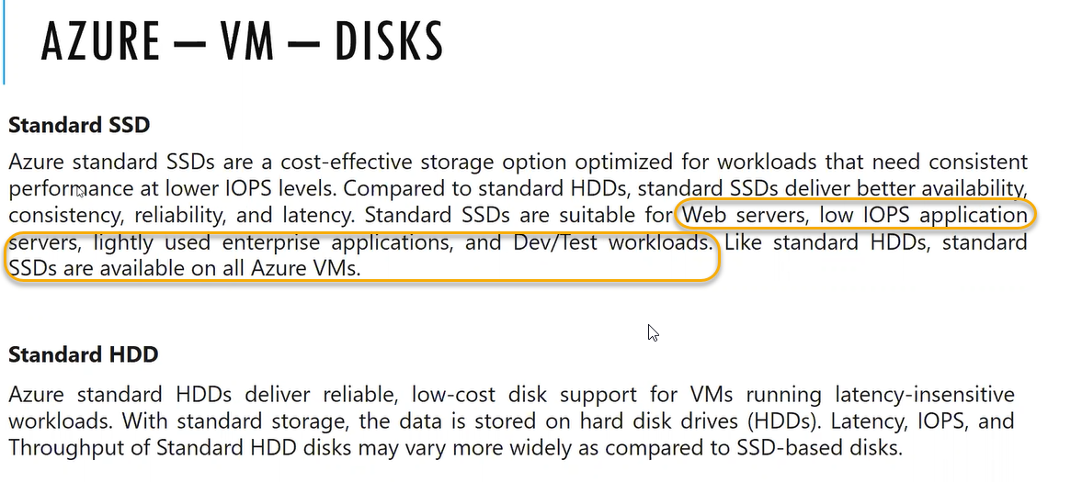

Ultra-disks will be available only if we set available zone in east Us

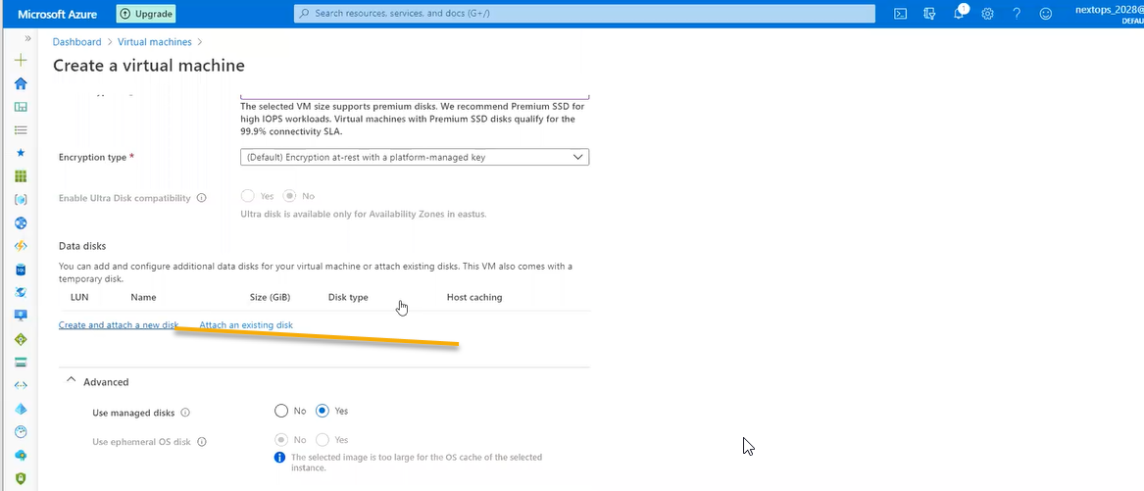

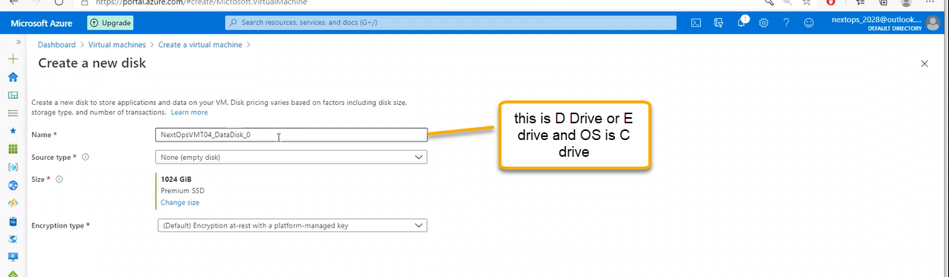

If you click on the change disk

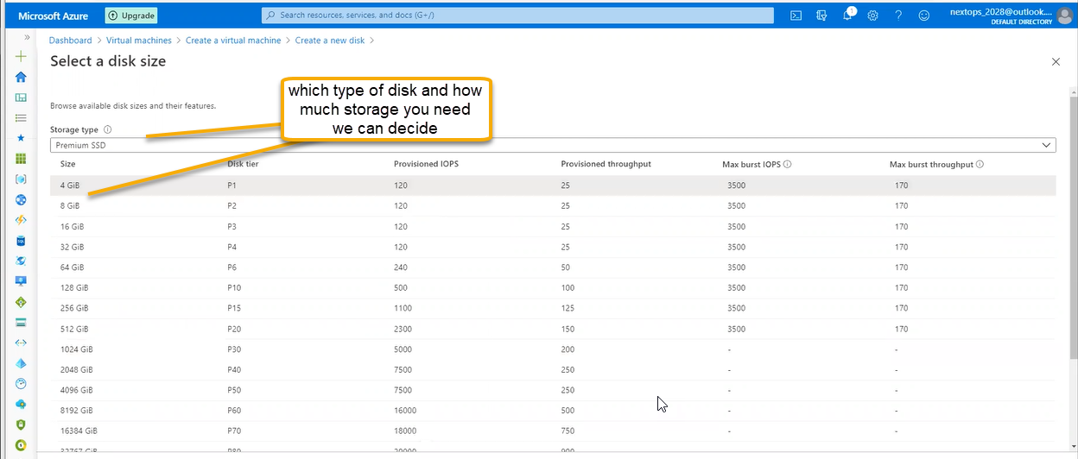

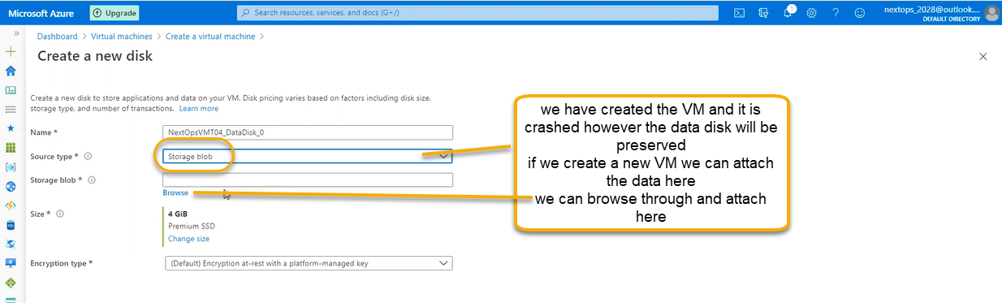

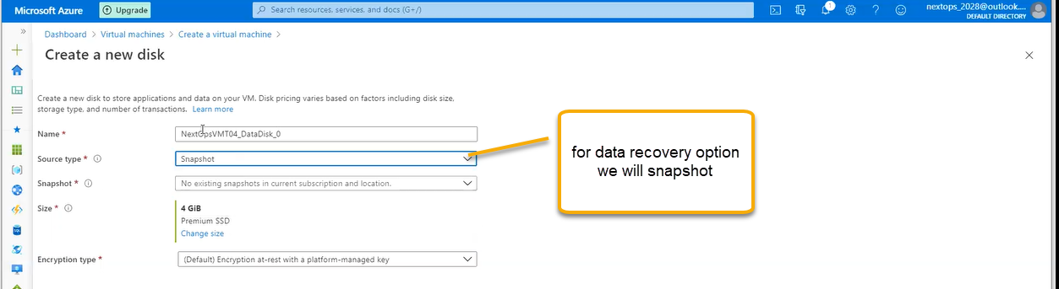

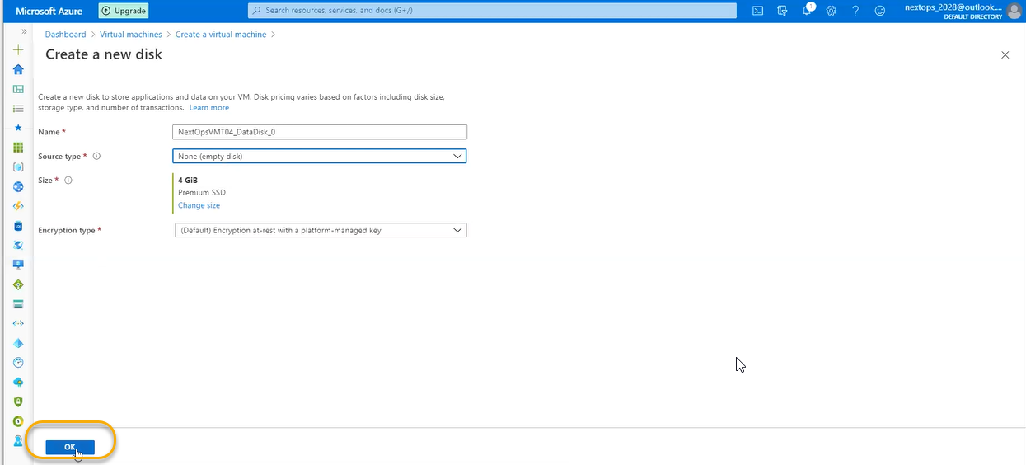

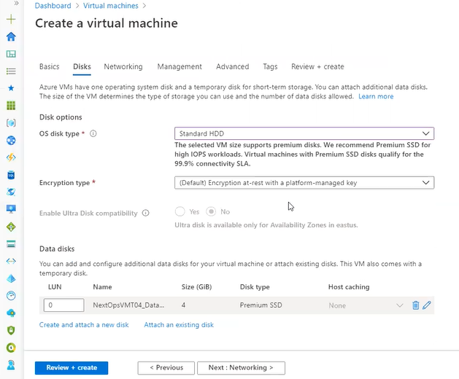

C, D and E disks are created. D is temporary drive